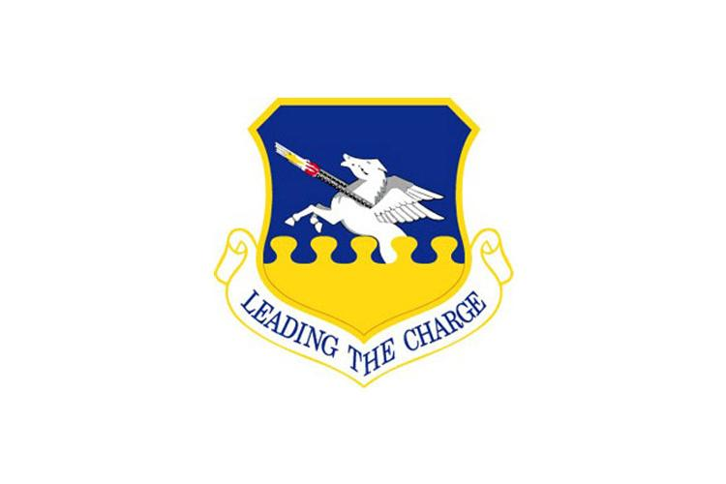**Osan Air Base**

Installation Advisory Committee (IAC)

**Purpose:**

**Advise** - Advise the Installation Commander on policies & programs in their purview.

**Foster Communication** – Committee serves in an advisory capacity. IACs do not have authority to direct the Installation Commander to take a certain action. The committee helps foster communications among administrators, military leaders, and local advisory committees.

**Facilitate Problem Solving** – The committee creates a process to address and resolve issues at the lowest level. They facilitate problem solving and recommends action to appropriate officials.

*As referenced in DoDEA AI 1358.01, Sec. 5.b.1/ Sec. 5.b.2*

**Recommended Voting Members:**

* Osan Installation Commander or designee: Col Kyle Grygo
* School Liaison Program Manager: Ms. April Kersey
* DoDEA High School Junior or Senior from SAC: N/A
* DoDEA Community Superintendent: Dr. Bailey *(absent)*
* OES Principal: Ms. Struhs
* OES Assistant Principal: Dr. Walker
* OMHS Principal: Ms. Braynt
* DoDEA District Instructional Systems Specialist: N/A
* OES Parent from SAC (Acting Chair): Erin Gray
* OMHS Parent from SAC (Acting Vice Chair): Heather Hoback

**Non-Voting Members:**

* A member of the exclusive bargaining unit representing DoDEA school employees from **OMHS** SAC (Acting secretary): Dr. Anselm
* A member of the exclusive bargaining unit representing DoDEA school employees from **OES** SAC: Ms. Oswald
* Any organization or agency pertinent to agenda items may attend, as needed
* DoDEA District employees

**Agenda**

1. **Call to Order-** School Liaison:
   1. **Start time:** 1604
2. **Introduction to IAC-** School Liaison
   1. **See first paragraph, page 1**
3. **Introduction to attendees –** Around the room
   1. Osan Installation Commander or designee: Col Kyle Grygo
   2. Osan Deputy Director/MSG: Mr. Brown
   3. School Liaison Program Manager: Ms. Kersey
   4. OES Principal: Ms. Struhs
   5. OES Assistant Principal: Dr. Walker
   6. OMHS Principal: Ms. Braynt
   7. OES Parent from SAC (Acting Chair): Erin Gray
   8. OMHS Parent from SAC (Acting Vice Chair): Heather Hoback
   9. OMHS SAC (Acting secretary): Dr. Anselm
   10. OES SAC: Ms. Oswald

Parent Attendees:

OES: 1

OMHS: 2

1. **Old Business:**
   1. Traffic Congestion Update- Mr. Brown
      1. Ms. Struhs suggested a new traffic flow at the beginning of the year and that is working out well.
      2. Security Forces provides traffic control points as much as possible in the morning to minimize traffic congestion.
   2. Osan Elementary School & Osan Middle High School Crosswalks
      1. Signup Genuis, 0715-0830, OMHS

[**https://www.signupgenius.com/go/5080848A4AB2BA0FE3-47106772-omhs**](https://www.signupgenius.com/go/5080848A4AB2BA0FE3-47106772-omhs)

* + 1. POC: SSgt Jeremy Robinson & Mr. Don Brown

1. **51 MSG CC/51 MSG DD**
   1. Col Grygo
      1. The Weapons Load Training Hanger will be available for the OMHS graduation ceremony.
      2. 51 CES contractors completed a traffic safety study in 2023. We have received the final report and are prioritizing resources for improvements such as more visible crosswalks and traffic circles that will smooth and calm traffic flow.
      3. 51 SFS is now issuing moving violation tickets for running stop signs and other unsafe driving. They will purchase radar guns and get the necessary training to start enforcing speed limits.
      4. We are continuously seeking volunteers for morning crossing guard duty; we appreciate any help with signups.
      5. Regarding how the base handles foul weather, road condition changes, and possible school delays. We closely monitor weather reports to give as much advance notice as possible, but always balance early decisions on school delays with executing our mission. Our CES road crews do a fantastic job controlling snow and ice and providing acceptable driving conditions.
      6. 51 FW continues monthly senior leader meetings with DoDEA to maximize communication and partnership.
      7. The upcoming Osan townhall will be held on February 14 at 1700 O Club.
   2. Mission Support Group Deputy Director: Mr. Brown
      1. Osan leadership will continue to proactively partner with DoDEA to achieve smooth, August 2024 Pre-K implementation by working through pertinent decisions in a Pre-K working group.
      2. The Pre-K working group is striving to ensure adequate bus transportation for Pre-K children who live in the off-base commuting zone. DoDEA will provide child safety seats. Options are being discussed, and at present, we believe that we have enough buses for the Pre-K capacity expected for SY 24-25.
      3. FSS is planning for wrap-around care and assessing the impact on CDC enrollment.
2. **Principal Reports**
   1. OES
      1. Manning for the next year is reduced. OES will lose two teachers, but due to the Pre-K implementation, teachers can transition to Pre-K classrooms. Pre-K will only require one new teacher.
      2. The 4th and 5th-grade award ceremony is scheduled for next week
      3. Please attend SAC meetings to engage and help address raised concerns.
      4. A team from OES visited Okinawa to explore 21st-century learning. OES will return to its original structure, utilizing co-teachers to ensure students' needs are met. The insights from Okinawa will be applied in classrooms.
      5. Mid-year data cards, containing student scores, have been sent home to keep parents informed of their children's progress.
   2. OMHS
      1. 400 enrollments: MS 218, HS 182
      2. Reregistration is coming soon to gather information from the community on who is coming back in the next school year. We are looking for a 100% participation. This includes families coming back and withdrawing.
      3. We will see a decrease in teacher staffing by 1.5 next year as enrollment numbers are decreasing.
      4. Osan DoDEA schools have a new Administrative Officer starting February 19th.
      5. Senior Parent night is February 13th. This meeting will prepare parents for graduation (i.e. how to get to the hanger).
      6. OMHS students represented Osan well at Far East with outstanding behavior.
      7. Preregistration parent night is important for fifth graders coming to OMHS next year. The counseling team will be visiting OES soon.
3. **New Business:**
4. Vote on IAC members
   * 1. Chair: Erin Gray
     2. Vice Chair: Heather Hoback
     3. Secretary: Dr. Anselm
5. Sent from OMHS SAC: Parents would like an additional bus route at Godeok Apartments – Mr. Don Brown, commuting zone study
   * 1. Current commuting zones were established three years ago.
     2. A study between the housing office and logistics at DoDEA has been initiated.
     3. Although we aim for the study to be completed by April 1st, we are uncertain if, even upon revealing that a bus route should be added to Godeok, it will be feasible for the next school year. It may be implemented in phases, contingent upon the delineation of school zones and resource allocation to accommodate families in that area. We are aware of families relocating to that area.
     4. The base provides buses and bus drivers, but DoDEA covers the expenses for these services.
6. Parent input:
   * 1. Parents have noted that the area is experiencing rapid growth among military members and if we want to make Osan, the base of choice, then we should try to improve things such as this for the families that choose to come live here.
     2. Parents acknowledge that the transportation paperwork they signed did not include Godeok in the commuting zone.
     3. Parent discussed personal story. Everyday, their child must call their mom to get a taxi to pick them up and take them to after school activities.
     4. Parents suggested having another option such as the small Korean buses
7. Mr. Brown response: There are two options. Option one is working with Vehicle Supply Chain Operations Squadron (VSCOS) to justify adding authorizations for small buses and then waiting for VSCOS to provide the buses. Option two is request Logistic Cost Sharing (LCS) funds for buses that are provided by the ROK to USFK. However, USFK prioritizes LCS funds based on mission criticality and it is not likely small buses would ever make the cut. There have been conversations with DoDEA about leasing buses as a third option but their resources are also limited.
8. **Open Forum:**
9. **Closing:**
   1. The next IAC Meeting is scheduled for 9 APR 2024 at 1600 in Classroom 2 at the M&FRC.
   2. Meeting adjourned at 1640